Private Cloud Networking Architecture
1. Introduction
A private cloud network is a data center–level infrastructure designed to provide scalable, secure, and high-performance compute and storage services within an organization. Modern private clouds commonly adopt a leaf–spine (Clos) architecture to achieve low latency, high bandwidth, and horizontal scalability.

2. Data Center Network Architecture
Leaf–Spine Topology Overview
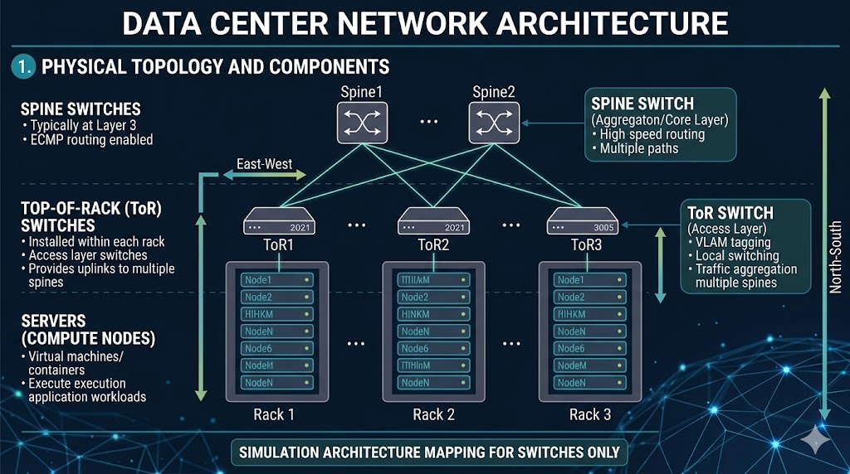

Key Components
2.1 Top-of-Rack (ToR) Switch
- Installed within each rack
- Connects directly to servers
- Functions as an access layer switch (Layer 2 or Layer 3)
- Provides uplinks to multiple spine switches
2.2 Spine Switch
- Forms the backbone of the data center network
- Connects all ToR switches
- Operates typically at Layer 3
- Enables equal-cost multipath routing (ECMP)
2.3 Servers (Compute Nodes)
- Host virtual machines or containers
- Execute application workloads
- Participate in east–west traffic communication

3. Functional Roles
3.1 ToR Switch (Access Layer)
- Connects servers within a rack
- Handles VLAN tagging and local switching
- Aggregates traffic and forwards it to spine switches
3.2 Spine Switch (Aggregation/Core Layer)
- Interconnects all ToR switches
- Ensures high-speed routing across racks
- Provides multiple equal-cost paths for traffic
3.3 Communication Flow
Traffic between servers in different racks follows:
Server → ToR Switch → Spine Switch → ToR Switch → Server

4. Detailed IP Addressing Design
A hierarchical IP addressing scheme is used to separate physical infrastructure (underlay) and virtual workloads (overlay).
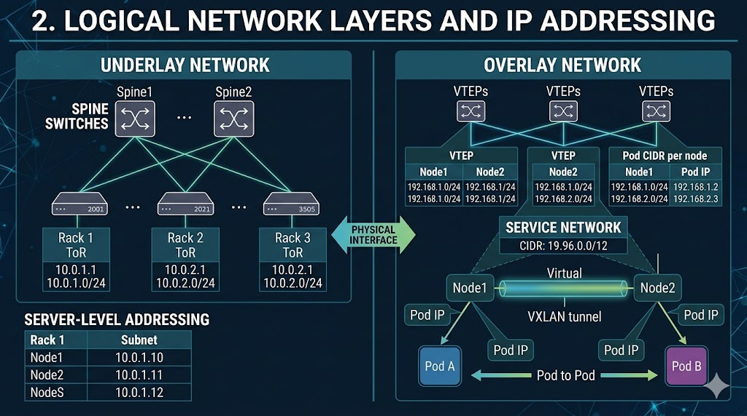

4.1 Underlay Network (Physical Infrastructure)
Used for switch-to-switch and switch-to-server communication.
Spine Layer
Spine1 → 10.0.0.1/24
Spine2 → 10.0.0.2/24
ToR Layer (Per Rack)
Rack | ToR IP | Subnet
Rack 1 | 10.0.1.1 | 10.0.1.0/24
Rack 2 | 10.0.2.1 | 10.0.2.0/24
Rack 3 | 10.0.3.1 | 10.0.3.0/24

4.2 Server-Level Addressing (Node Level)
Each server connected to a ToR switch receives an IP within the rack subnet.
Example: Rack 1
Server | IP Address
Node1 | 10.0.1.10
Node2 | 10.0.1.11
Node3 | 10.0.1.12

4.3 Overlay Network (Pod / VM Level)
Overlay networks are independent of physical topology and use VXLAN.
Node | Pod CIDR
Node1 | 192.168.1.0/24
Node2 | 192.168.2.0/24
Node3 | 192.168.3.0/24
Example Pods
Pod | IP
Pod A | 192.168.1.2
Pod B | 192.168.2.3

4.4 Service Network
Used for internal service discovery in Kubernetes.
Service CIDR: 10.96.0.0/12

5. End-to-End Communication Flow
5.1 Same Rack Communication
Pod A → Node → ToR → Node → Pod B
- No spine switch involved
- Low latency

5.2 Cross-Rack Communication
Pod A
→ Node1
→ ToR1
→ Spine
→ ToR2
→ Node2
→ Pod B
Detailed Flow Explanation
- Pod A sends packet to destination Pod B
- Packet encapsulated using VXLAN
- Sent to Node1 network interface
- Forwarded to ToR1
- Routed via Spine switch
- Delivered to ToR2
- Sent to Node2
- Decapsulated and delivered to Pod B

5.3 External Communication (North–South)
Client → Load Balancer → ToR → Node → Pod

6. Traffic Types
6.1 East–West Traffic
- Internal communication within data center
- Example: Pod-to-pod
6.2 North–South Traffic
- External communication
- Example: User accessing application

7. Routing and Protocols
7.1 Equal-Cost Multi-Path (ECMP)
- Distributes traffic across multiple spine switches
- Provides redundancy and load balancing
7.2 Border Gateway Protocol (BGP)
- Used in underlay network
- Enables scalable routing between switches

8. Network Virtualization
VXLAN
- Encapsulates Layer 2 frames into Layer 3 packets
- Enables cross-rack communication
- Supports multi-tenant environments

9. Simulation Architecture Mapping
Simulation Tools
- Containerlab
- Docker
- Kubernetes

Mapping Table
Real Infrastructure | Simulation Equivalent
Spine Switch | Container (router)
ToR Switch | Container (switch/router)
Server | Kubernetes node
Pod | Container

10. Monitoring and Metrics
Key Metrics
- CPU utilization per node and pod
- Memory utilization
- Network throughput
- Latency
Tools
- kubectl top
- Prometheus
- Grafana

11. Security Considerations
- VLAN/VXLAN-based segmentation
- Access control lists and firewall policies
- Kubernetes Network Policies

12. Advantages of Leaf–Spine Architecture
- Predictable latency (1–2 hops)
- High bandwidth availability
- Horizontal scalability
- Fault tolerance

13. Limitations in Simulation
- Shared CPU and memory in local environments
- Lack of physical isolation
- Limited bandwidth compared to real data centers
Despite these limitations, simulation accurately represents logical behavior.

14. Conclusion
Private cloud networking uses a leaf–spine architecture combined with underlay and overlay networking to enable scalable and efficient communication. A structured IP addressing scheme across spine, rack, server, and pod levels ensures proper routing and isolation. Simulation tools such as Containerlab, Docker, and Kubernetes provide a practical platform to replicate and analyze this architecture.

